**Entrust Certificate Authority**

Generate certificates through Entrust if the request has option selected **\*Yes\*** in the Task.

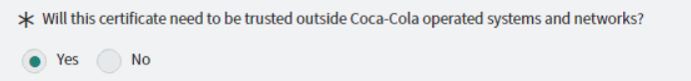

In order to Create the SSL Certificate from Entrust proceed to

<https://login.entrust.net/IdentityGuardFederation/authentication/firstFactorAuthentication>

Enter the desired credentials which has been mentioned on **Coke USB_VPN** sheet.

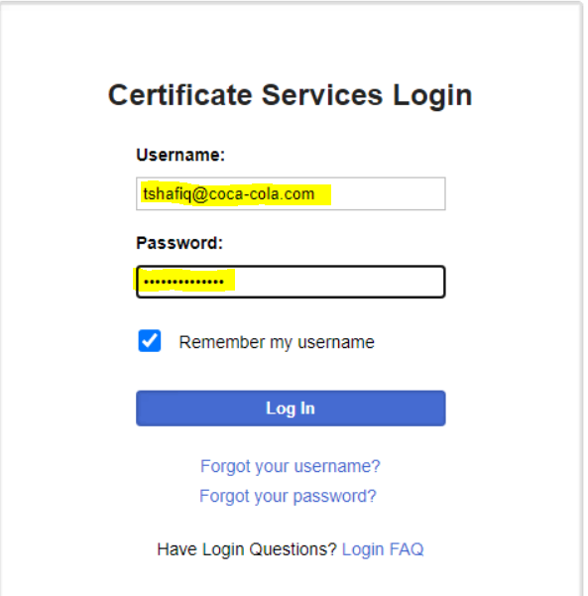

After enter Username and Password. Need to verify Authentication from E-grid image which is also provided on **Coke USB_VPN** sheet.

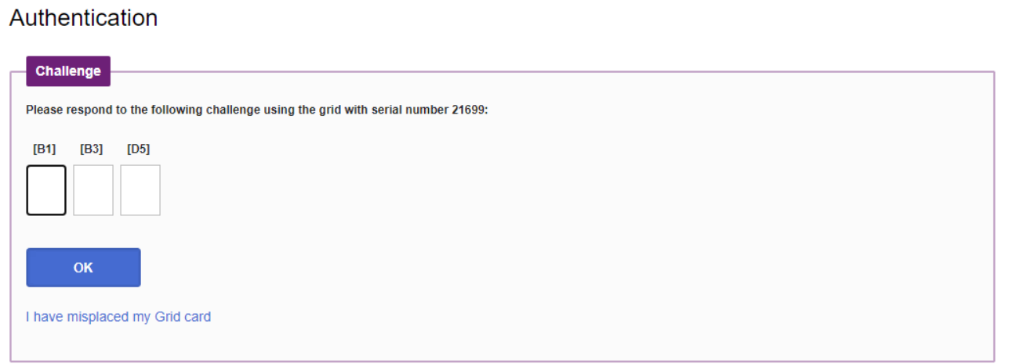

Once login into the Entrust Certificate Authority portal.

On navigation bar Click on **Create** > **SSL/TLS**

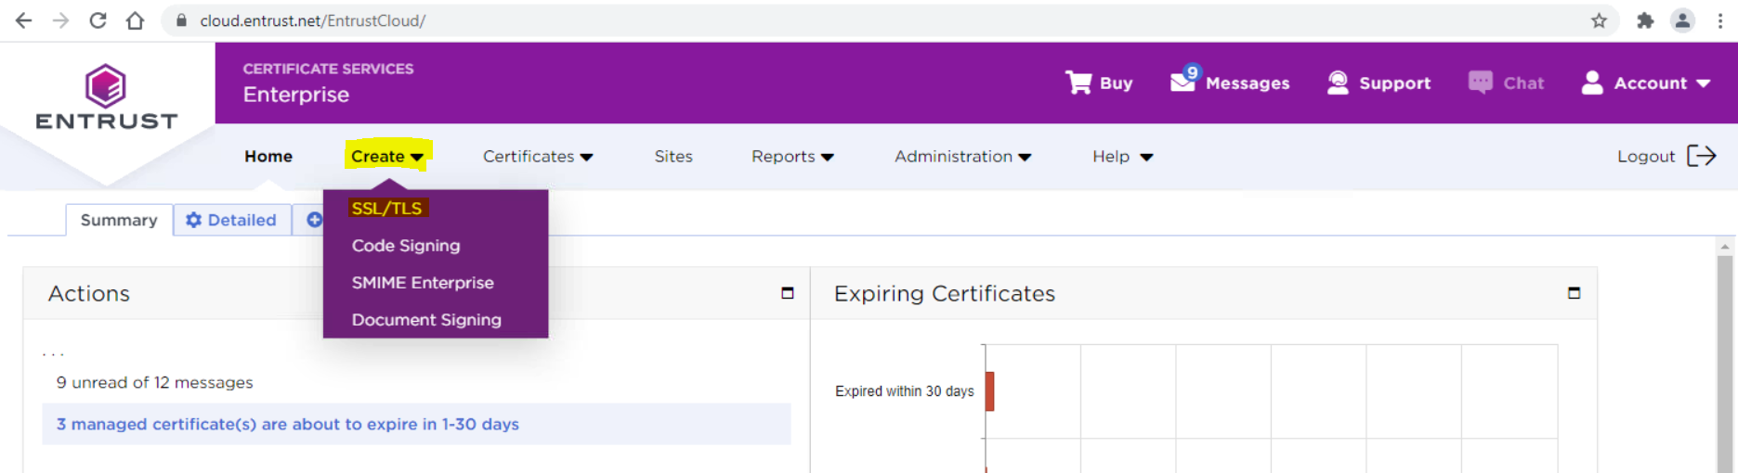

Depend on the Request choose the desire state to generate the certificate and click 

(**Hint**)

* If the request has single domain or sub domains choose Standard OV.
* If the request has multiple domains or sub domains choose Multi-Domain OV

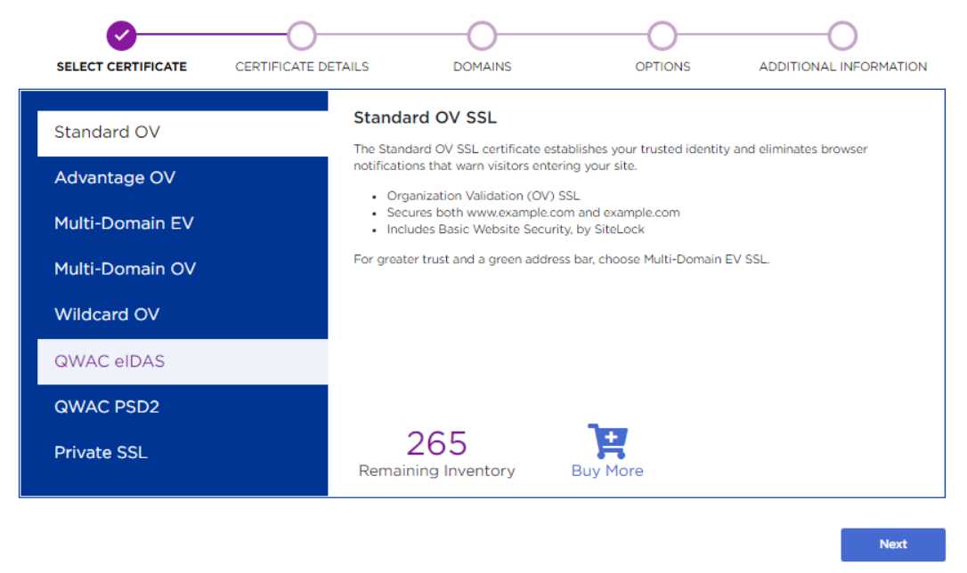

After choosing the required option Click Next.

Paste the provided CSRwhich has been shared with you over the CCSN and make sure the Highlighted Organization Filed has change into **The Coca-Cola Company** after pasting the CSR and then click **Next**

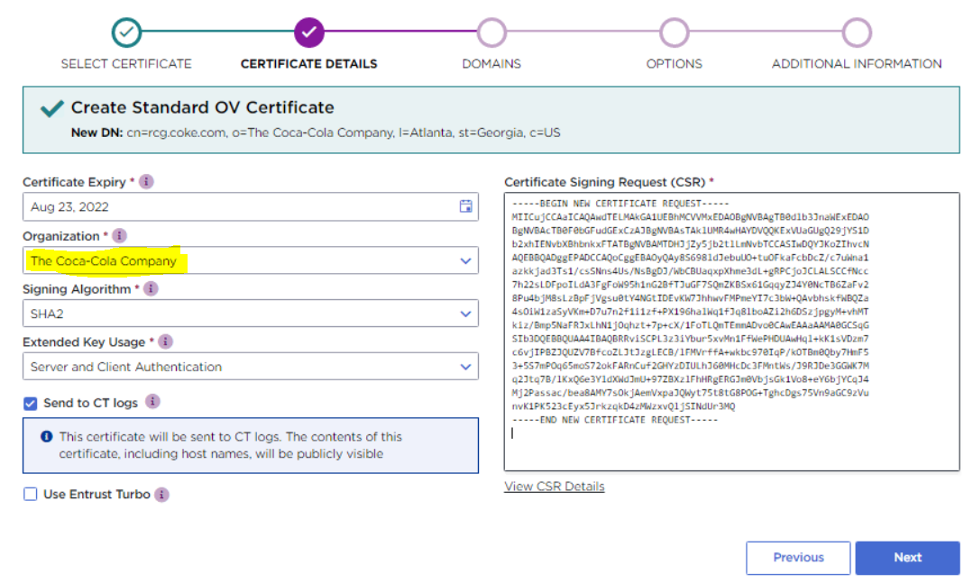

By Default, Entrust include one domain.

Click on Include all if the Child /Sub domain are not selected. Verify it by checking the status and then click **Next**.

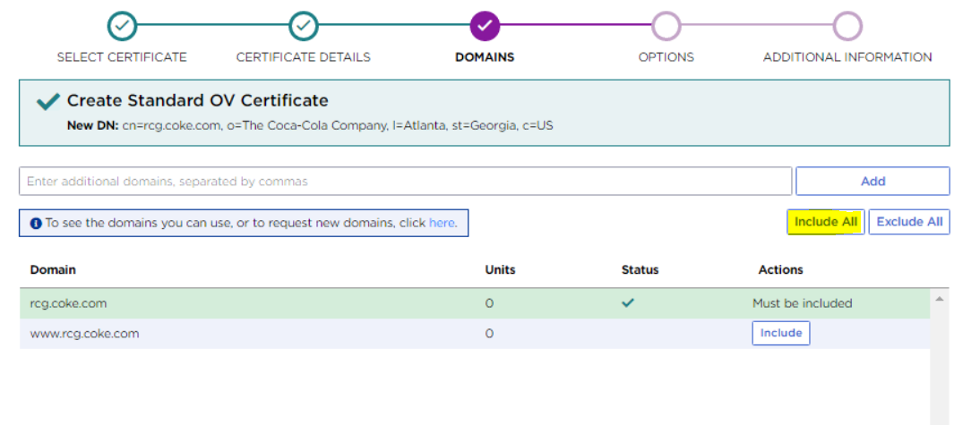

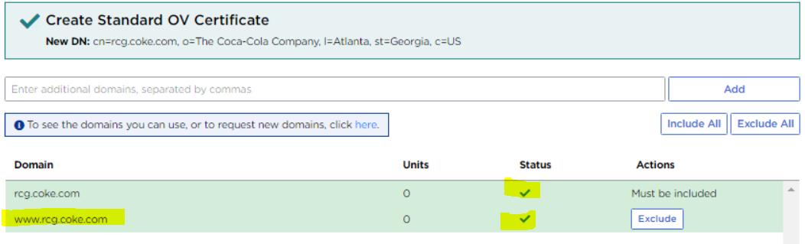

In SSL Certificate Request if is there any additional domains which are needed to be added in SAN’S.

Select the domain name from request and paste it on highlighted column and proceed it too **Next**

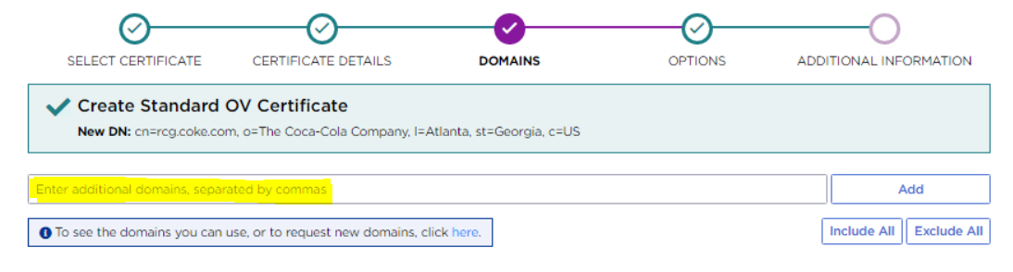

Click **Next**

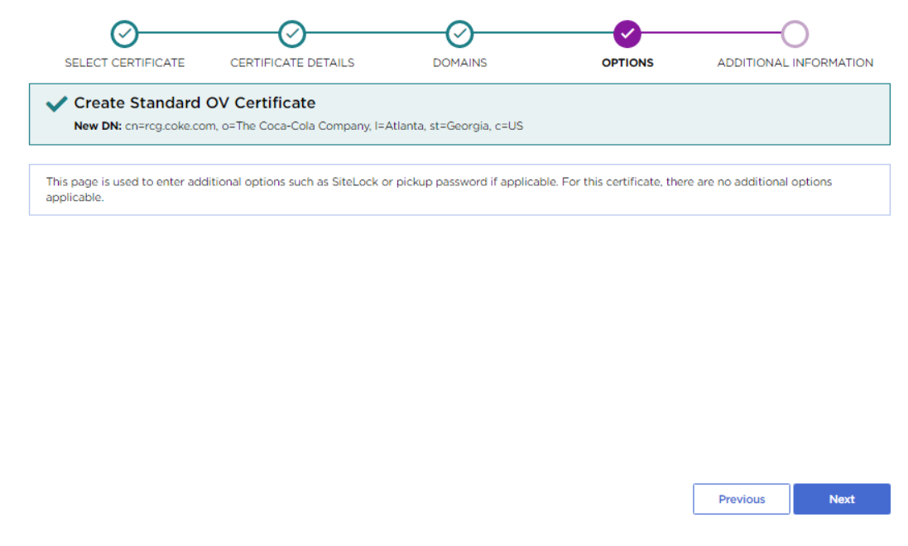

In Additional Information section

* Certificate Friendly Name > **TASK-RITM Number**
* Additional Email > **The Requester Email address**

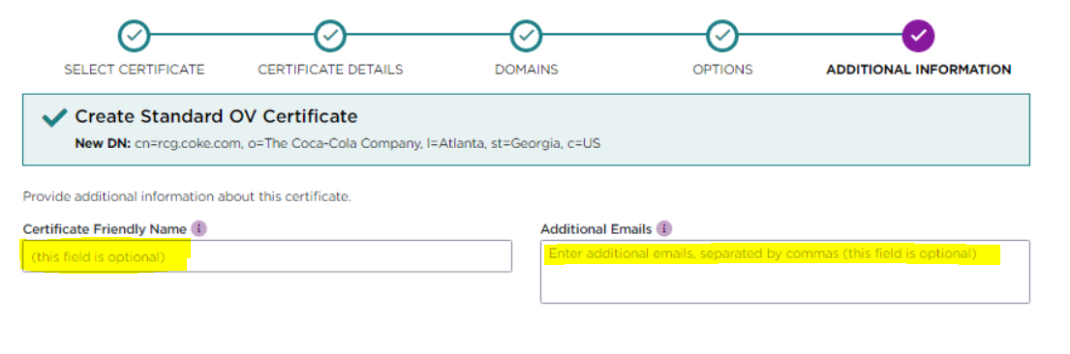

(**Hint**)

For above image columns...

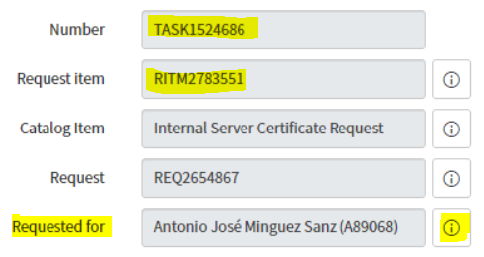

Once all the provided information for SSL certificate has been submitted in respective fields Click **Submit** and then **Yes** to generate the certificate.

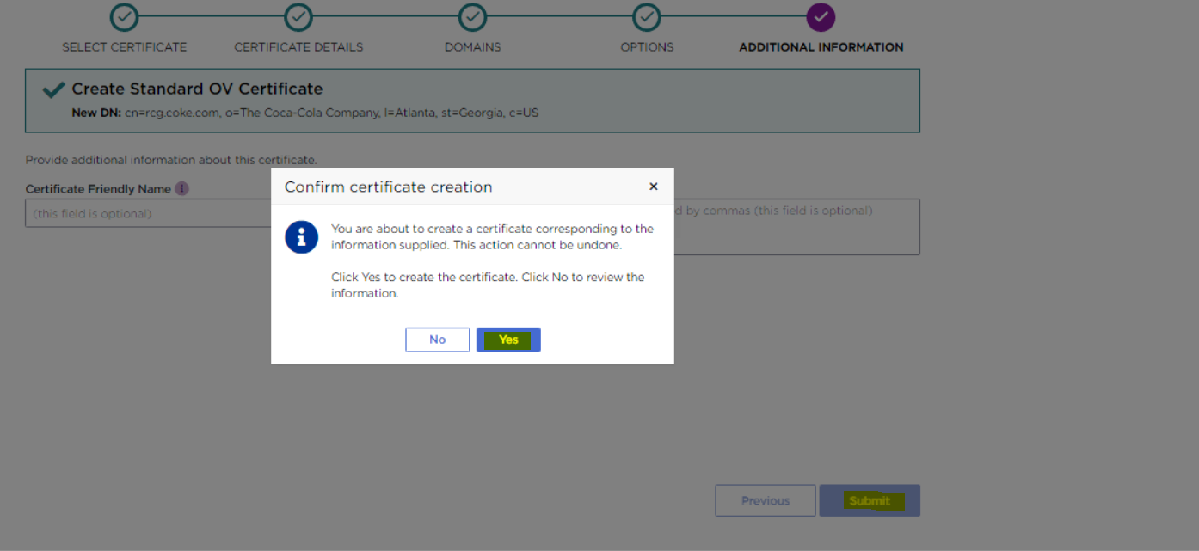

After 5 to 10 second the mentioned image will pop-up on a same browser window which mean certificate has been generated.

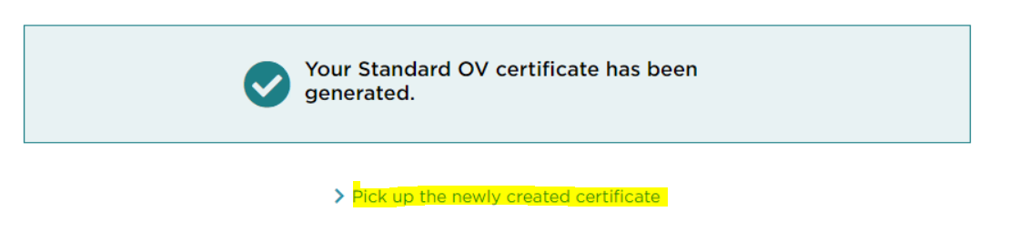

Download the certificate by clicking on Highlighted link it will take you another Screen.  
Do not change anything and

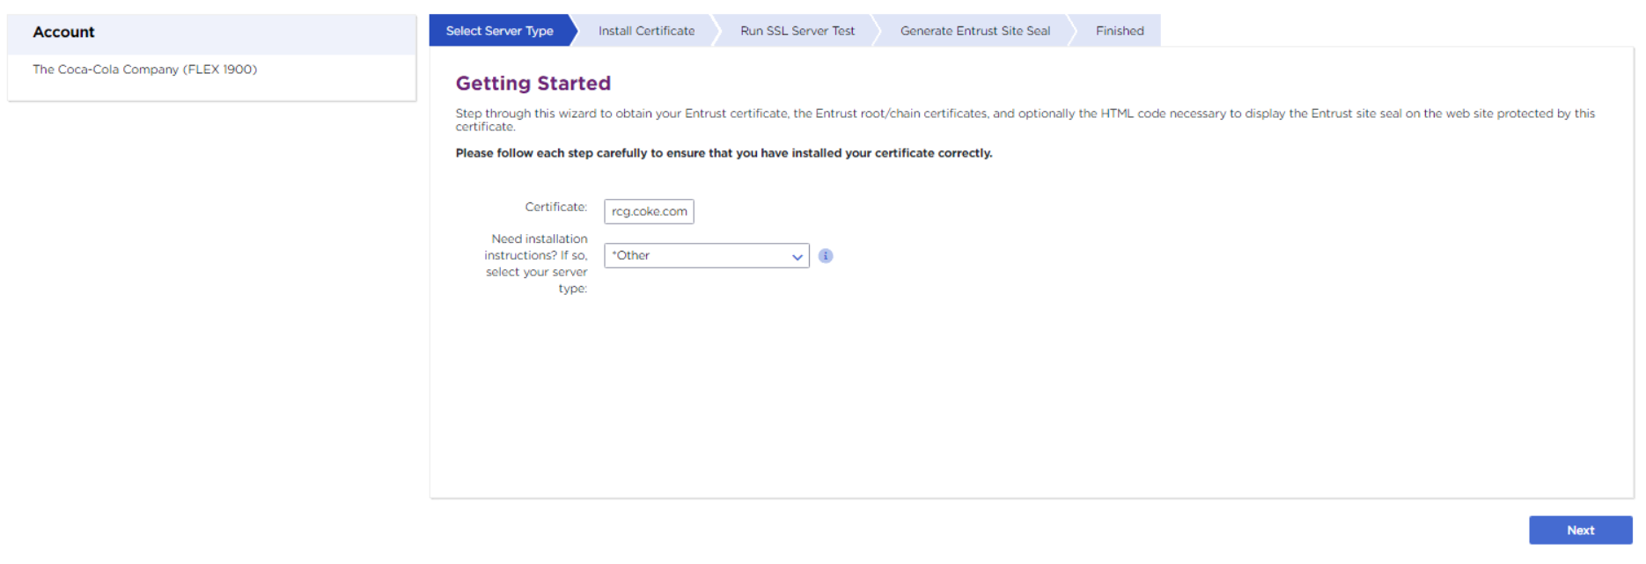Just Click on **Next**

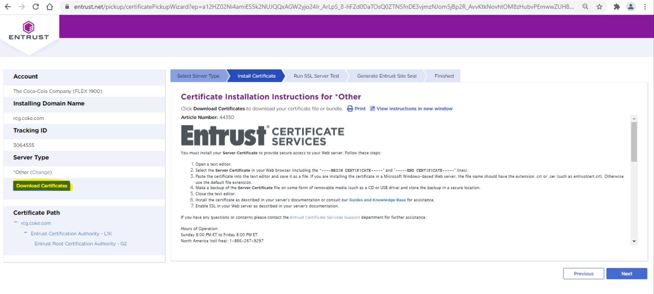Download the certificate from highlighted Download button and share the certificate to client over **CCSN request** > **Update the Work Note** > **Change State into Close Task**.